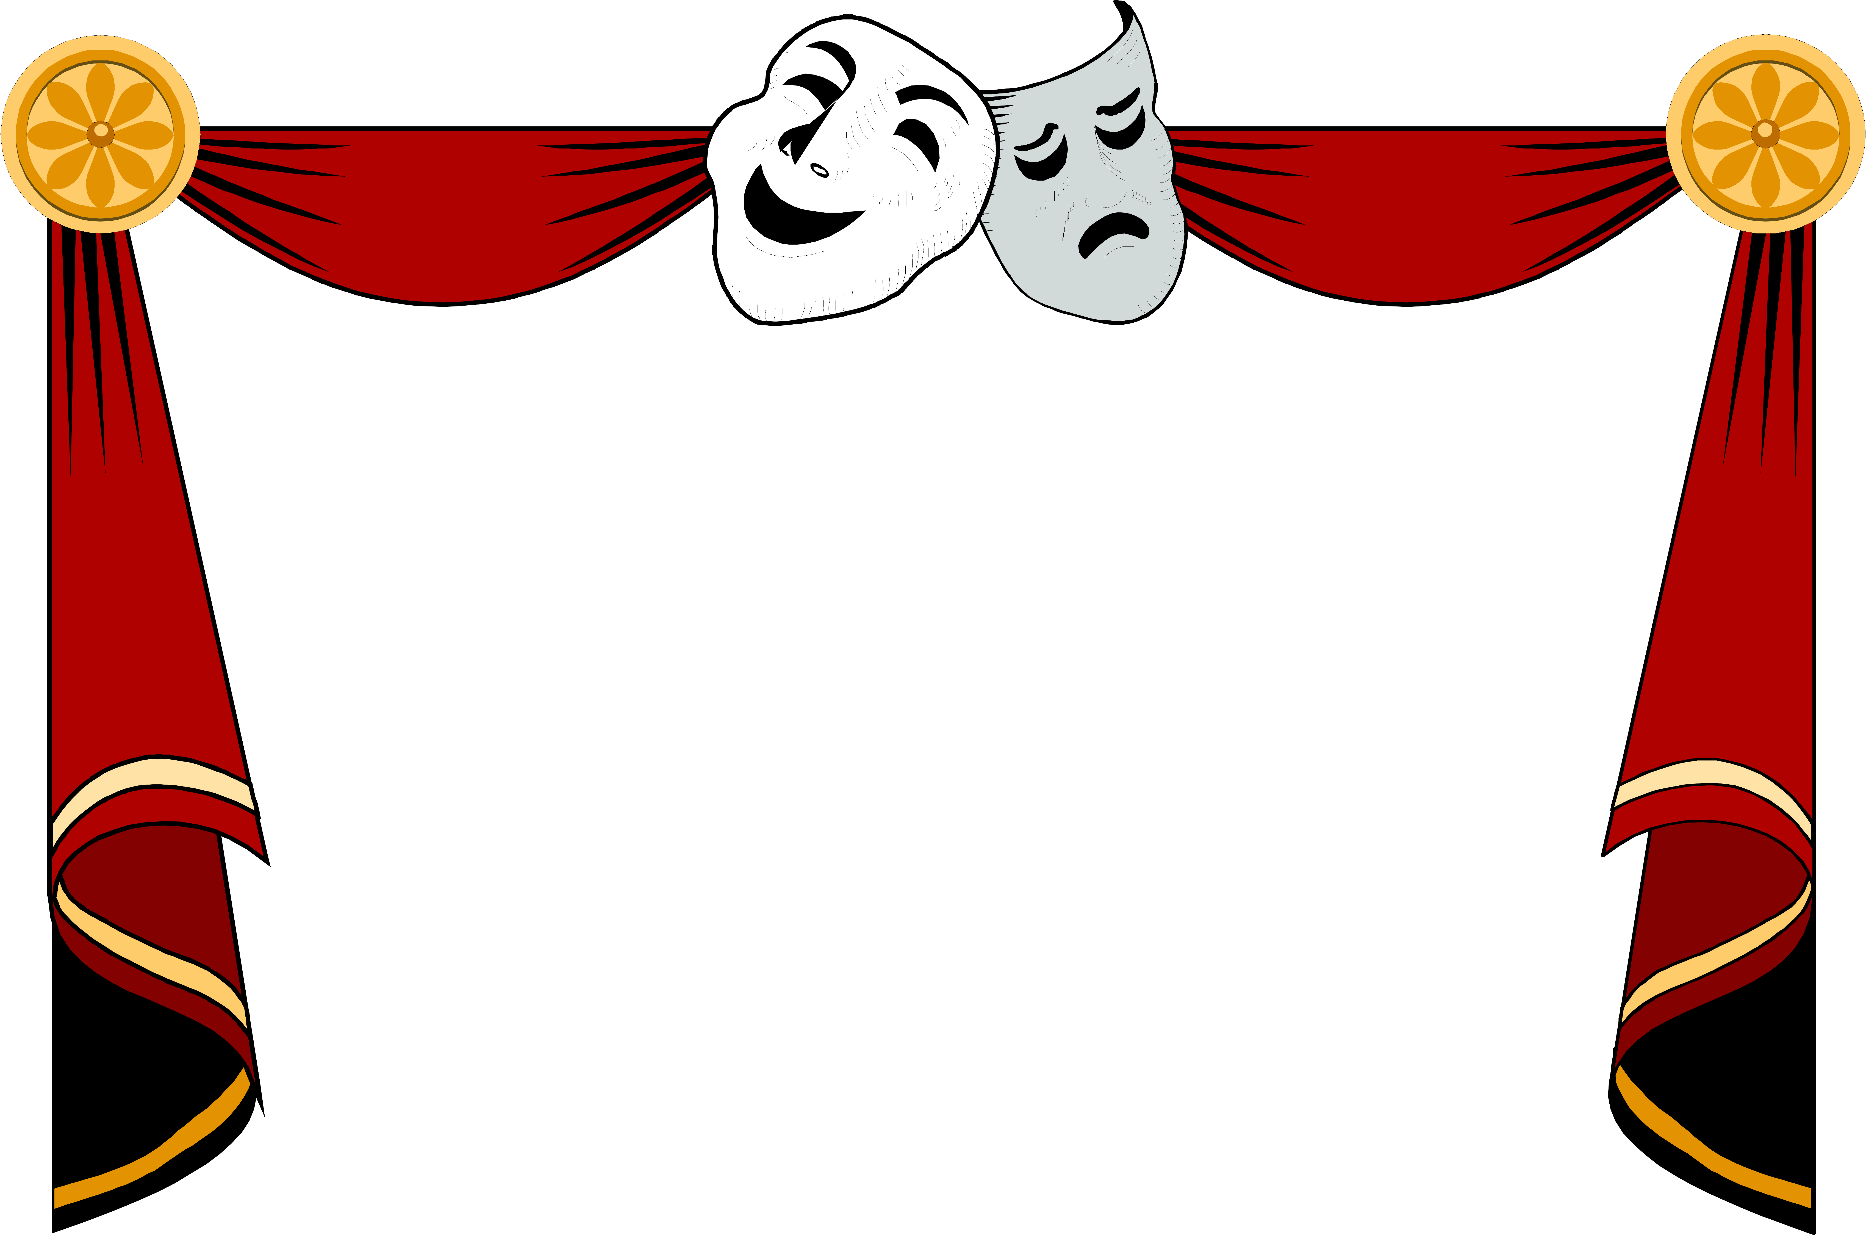
Penterry Players
Murder Mystery Evening
Dead on Cue

- Team Name

- Table number

- Who killed marcia fitzwilliam?

- Why?

- How was the sedative administered?

- How was she killed?

